User End dating application change and development log

Version 2
11/01/2023
- Adjusted the location return information presented to create space for the addition of an email delegate.
- Adjusted the spacing of the return data to be clearer for error handling.
- Corrected some spelling and grammar errors in return data
- Added email delegate button
- Rearranged to a square layout
- Adjusted frame size
- Added label demarking optional email delegate
- Added label for delegate enumber
- Added capture field for delegate enumber
- Added the v6 removal using recycled known good code not tested

UI change
v2  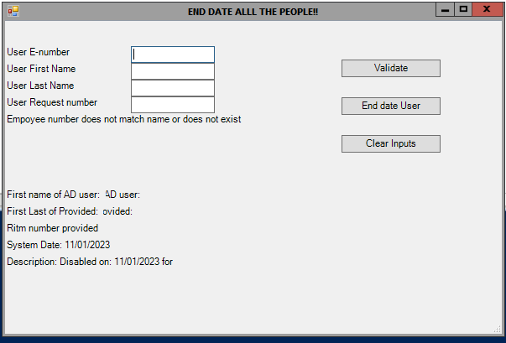 | V3  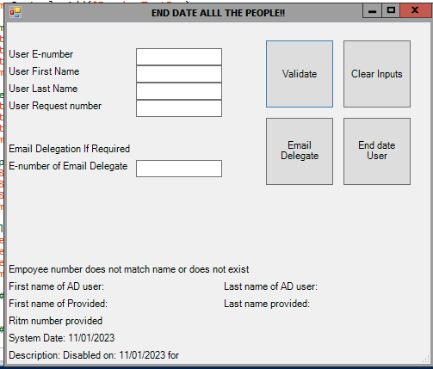

12/1/2023

- Added epics into the security group removal
- Added connect exchange,
  - This currently does not work in sgja298
  - look at pivot options:
    - migrate the app off 298 (ideal)
    - add exchange connect functionality to 298 (may get pushback)
    - pause the current project pending clarification on this

16//01/23
Roll back:
I have completed a separate application that when run externally from the domain controller will complete the email functionality.
For now:
- keep altered UI changes.
- Add the code from the other application.
- Block out the code.

Version 3
12/1/2023

- Added epics into the security group removal
- Added connect exchange,
  - This currently does not work in sgja298
  - look at pivot options:
    - migrate the app off 298 (ideal)
    - add exchange connect functionality to 298 (may get pushback)
    - pause the current project pending clarification on this

16//01/23
Roll back:
I have completed a separate application that when run externally from the domain controller will complete the email functionality.
For now:
- keep altered UI changes.
- Add the code from the other application.
- Block out the code.

Version 4
16/01/23
- Added a non-editable message return box, and moved all message return functionality to this box.
- Moved all return messages to the message box
- Changed the validation switch to a Boolean value
- Added functionality for a log to be generated called the request number in a folder called logs
- Updated the application name
- Refactored some unused lines
- Added functionality for the clear button to wipe the return message
- Added a clean-up function to the go button to stop instances sharing validation after work.
- Added a gating if statement mandating item number for progression
- Added a gating if statement checking if the user has already been end-dating prior to progressing

Version 5
26/1/2023
- scope:
- - Address the issue of the user able to change data post validation possible error
- - move the end date button so it is not hit when targeting the clear button reducing user error potential.
changes:
- - added a read-only lock for input fields that are active when validation is true.
- - added a read-only = false to the end of the go function and the clear function
- - moved return msg box up for aesthetics
- - moved the end dating button to the bottom away from the validate and clear button
- - test within the test environment have been successful
- - prepping documentation and submitting for review for Prod release

